CHAPTER 8 – ERROR AND EXCEPTION HANDLING
TOPICS COVERED
8.1 WHAT IS ERROR AND EXCEPTION
8.2 COMMON REASONS FOR EXCEPTION
8.3 TYPES OF ERROR AND EXCEPTION
8.4 EXCEPTION HANDLER COMPONENTS
8.5 RAISING AN CUSTOM EXCEPTION
8.6 ACHIEVING ASSERTION ERROR

8.1 WHAT IS ERROR AND EXCEPTION
Error:
- In Python, An Error is recognized as a misbehaved part with in source code program.
- Errors can be detected and found by the parser when it detects an incorrect statement
- Errors are described as violation statements in a python script.
- Most common reason of an error in a python program will be found when a certain statement or condition which is not appropriate with intended usage.
Exception:
- Exception means an unwanted or an unexpected event that disrupts the normal flow of program execution.
- Exception is also known as error which occurs only during the program execution and if it is not caught, program will be terminated and crashed.
- Exceptions are triggered automatically on errors and it can be intercepted by the source code.
8.2 COMMON REASON FOR EXCEPTION
- Exceptions could arise in a program due to following reasons,
- User has entered invalid data
- Insufficient inputs given
- File needs to be open, cannot found in the system
- Virtual machine running out of memory
- Network connection lost in the middle
8.3 TYPES OF ERROR AND EXCEPTION
Error:
Syntax error – occurs only when parser detects an incorrect statement written by responsible user. Hence user is responsible for this type of errors.
Runtime error – Occurs for many reasons mentioned in previous chapter(this type of errors are also called as exceptions)
Exception:
- IndexError
- ModuleNotFoundError
- KeyError
- ImportError
- TypeError
- ValueError
- NameError
- ZeroDivisionError
SAMPLE CODING FOR EXCEPTIONS
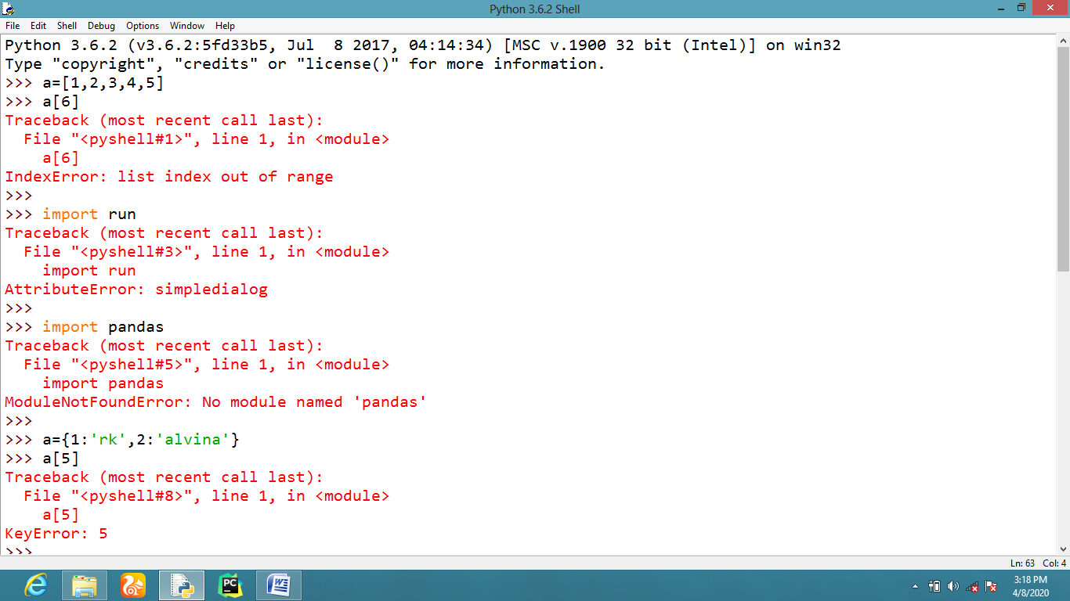
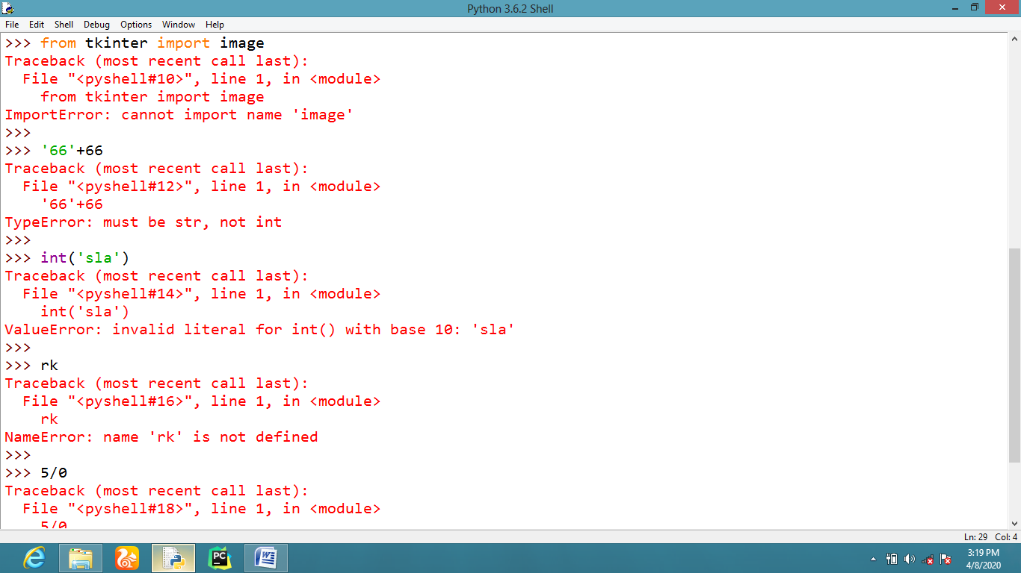
8.4 EXCEPTION HANDLER COMPONENTS
try – This block contains conditional statements of a python source code to find the
misbehaved part with in program. This try block statements will be immediately
followed by except statements.
except – This block contains statements to perform an action against the found exception
caught by try block otherwise it returns an error message from default exception
hierarchy.
finally – this block contains the must execute code to be displayed during program execution.
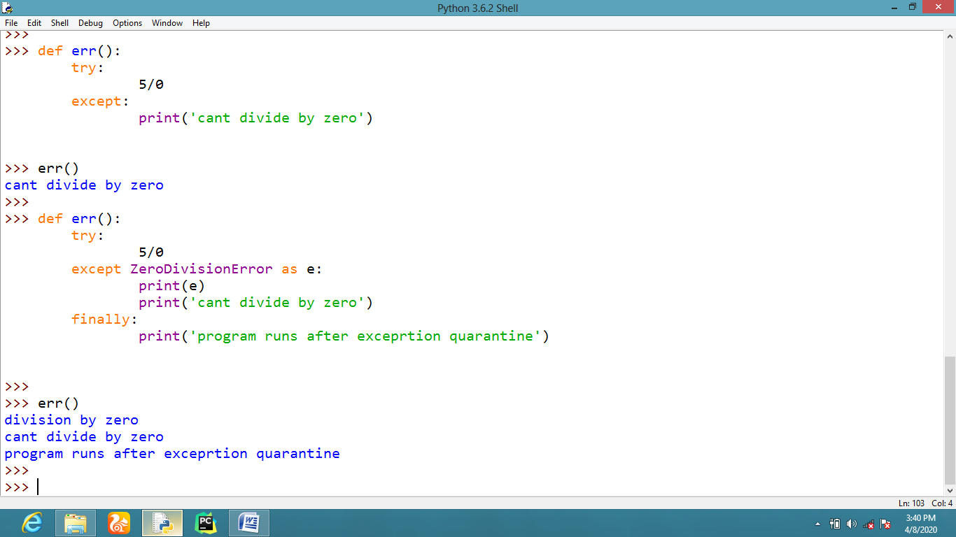
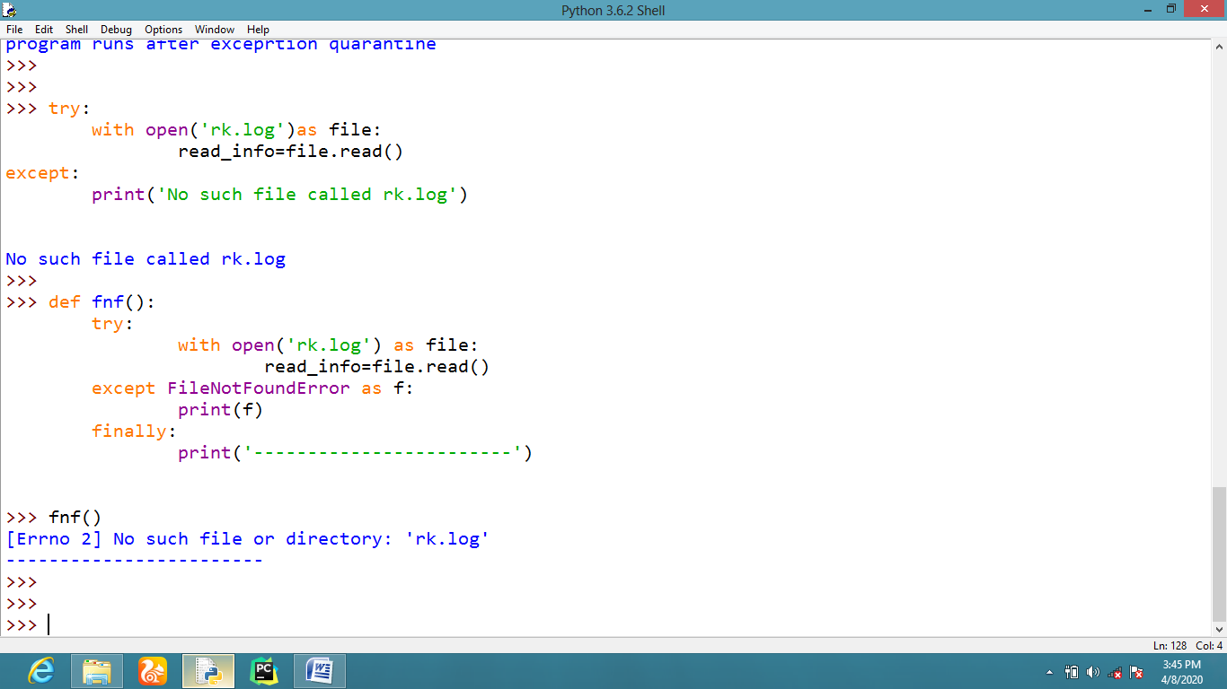
8.5 RAISING AN CUSTOM EXCEPTION
Python exception hierarchy allows the user to create and raise custom user defined exceptions with the help of “raise” keyword.
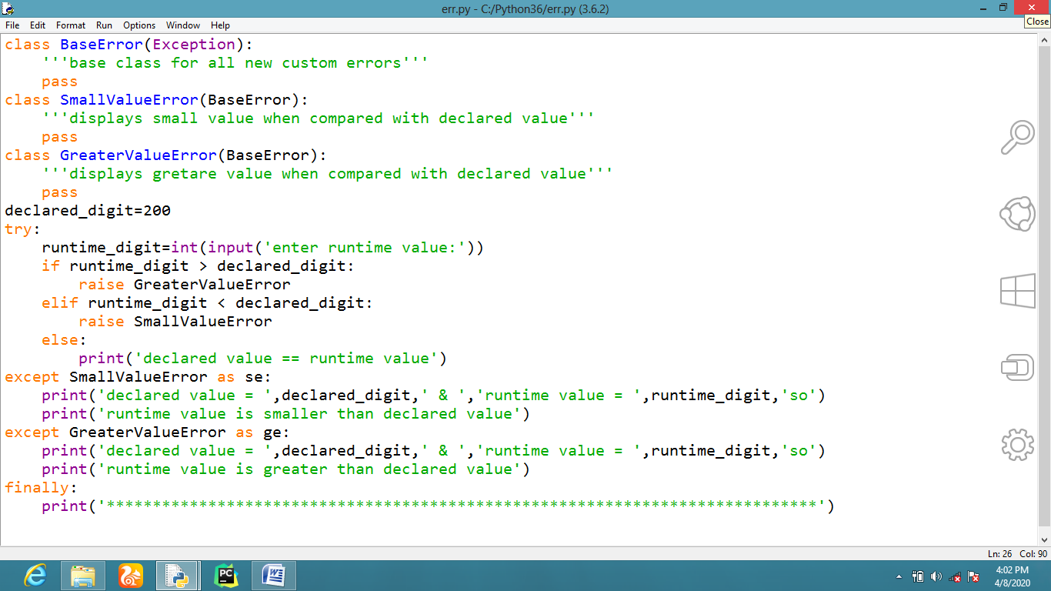
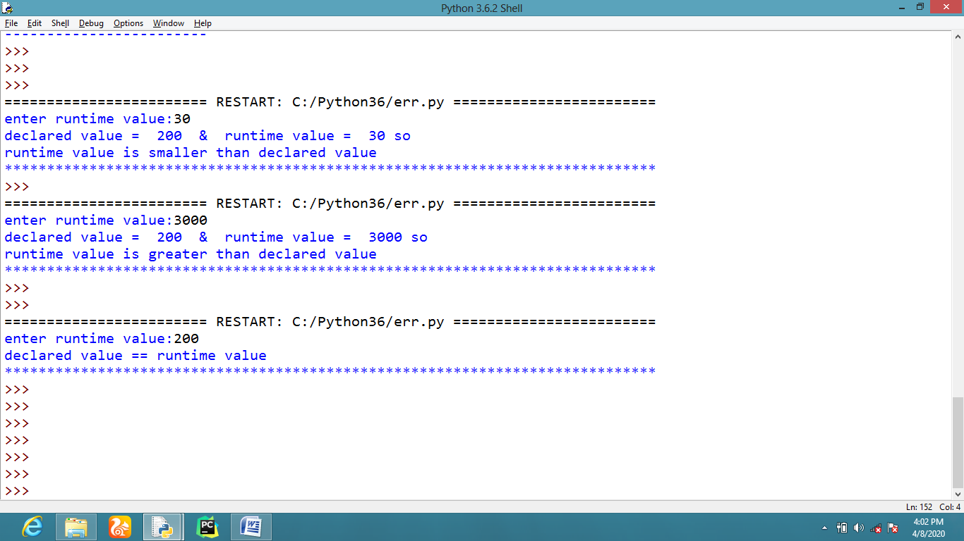
8.6 ACIHEVING ASSERTION ERROR
- When an assert statement is used within a python program it needs to be met the given test condition otherwise it returns assertion error exception.
- In other words, assertion used in program needs to be true all the time.
